Acme File Sharing

By Jayviar Laporte

Hello and Welcome! Below is the step-by-step documentation on how we will be file sharing.

Setting up the file share:

* To begin. We will power on both of our virtual machines and open the terminal if not already done.

*This is recommended for this demo. Our screen should look like the image below*

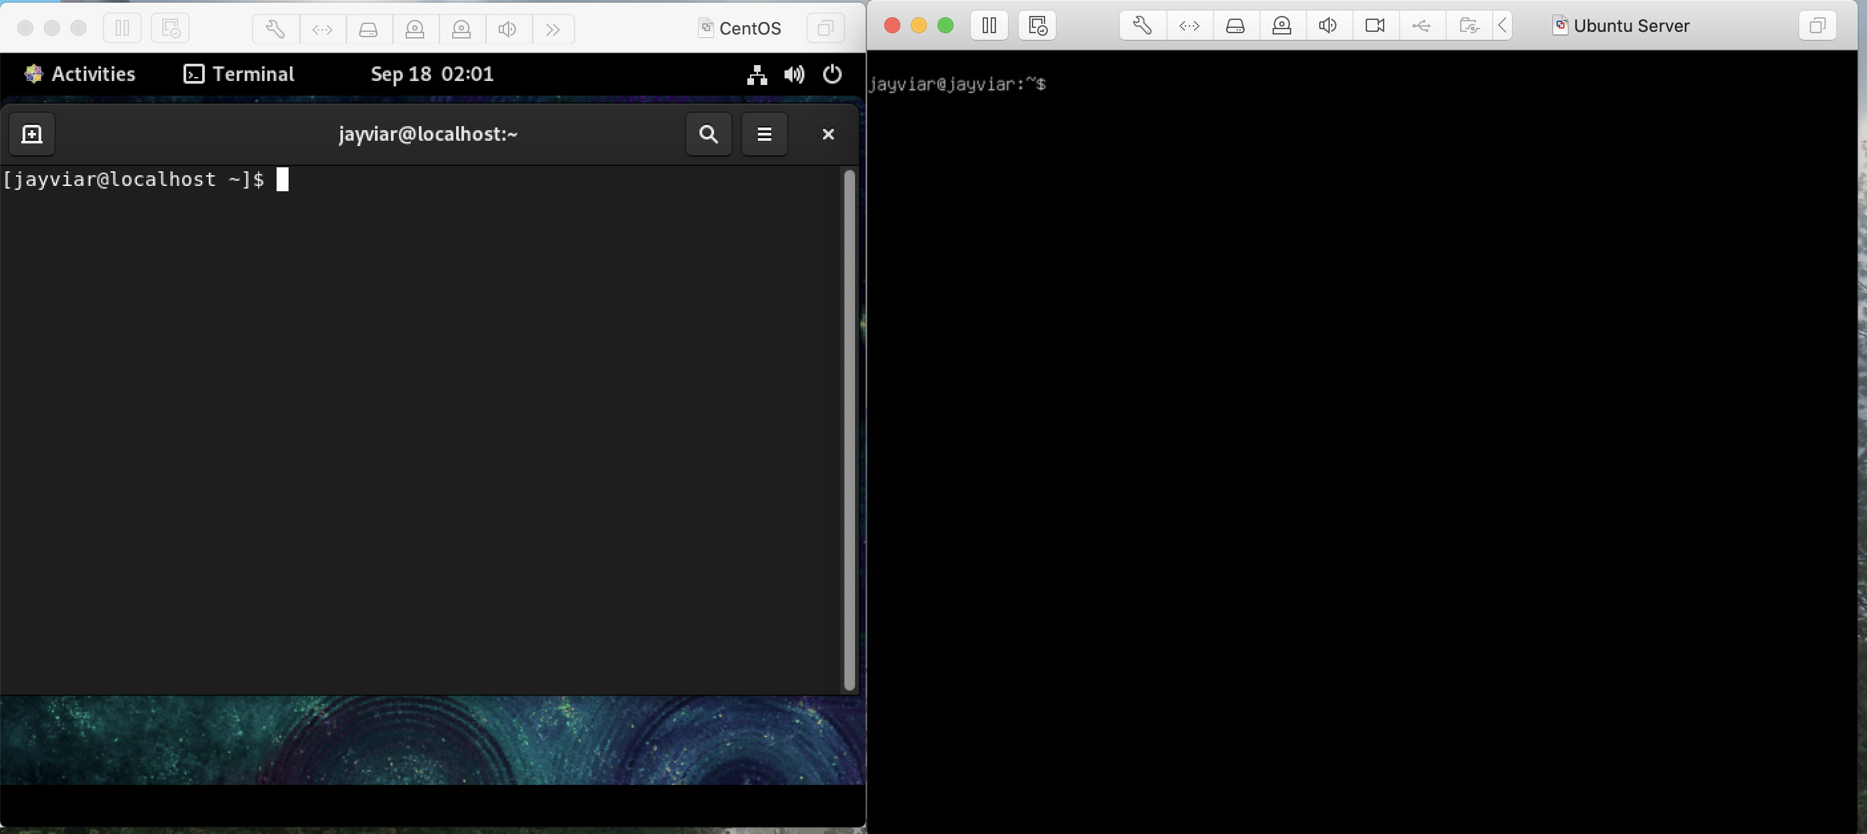

1)

Next, we want to just make sure the two servers can talk to each other. We will test this by simply pinging each of them to one another.

*In this example we use the ping command and then use the IP addr of the opposite server to test valid communication.*

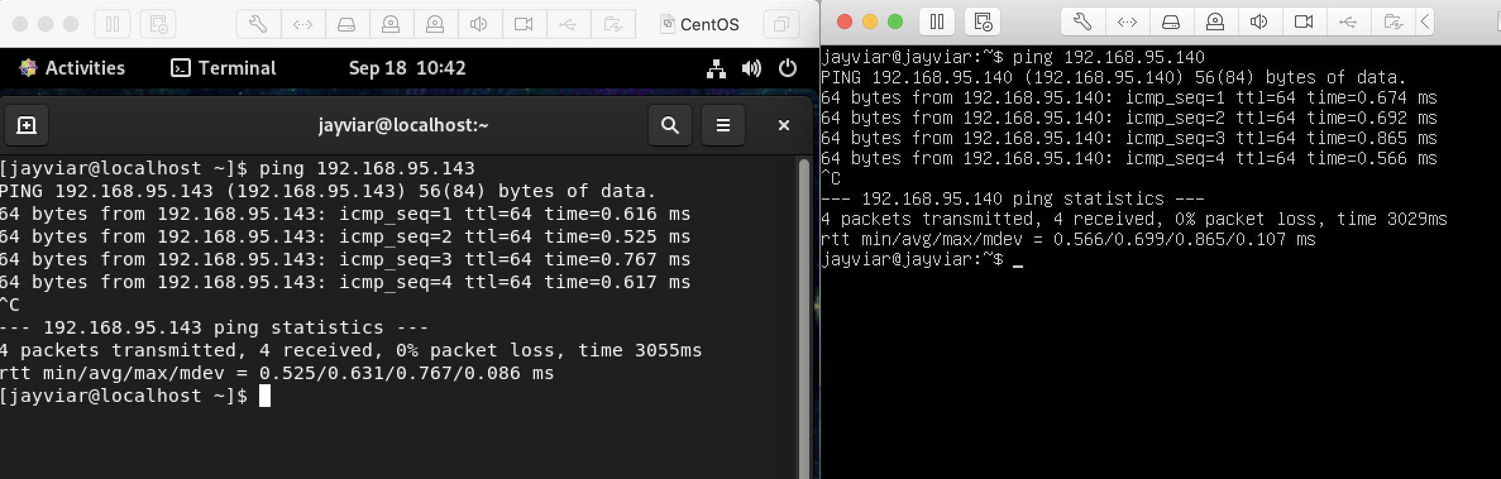

2)

Now, we will officially begin the file share. In this demo we will specifically be using SCP. However, if you would like to use another form of file sharing you may. In this demo we will be creating a new file on our CentOS Server then sending it to our Ubuntu Server using SCP. To create a new file, we will use command nano then whatever name we want the file to be

*Below is where we should be when the command is run and some brief text to describe what is in it*

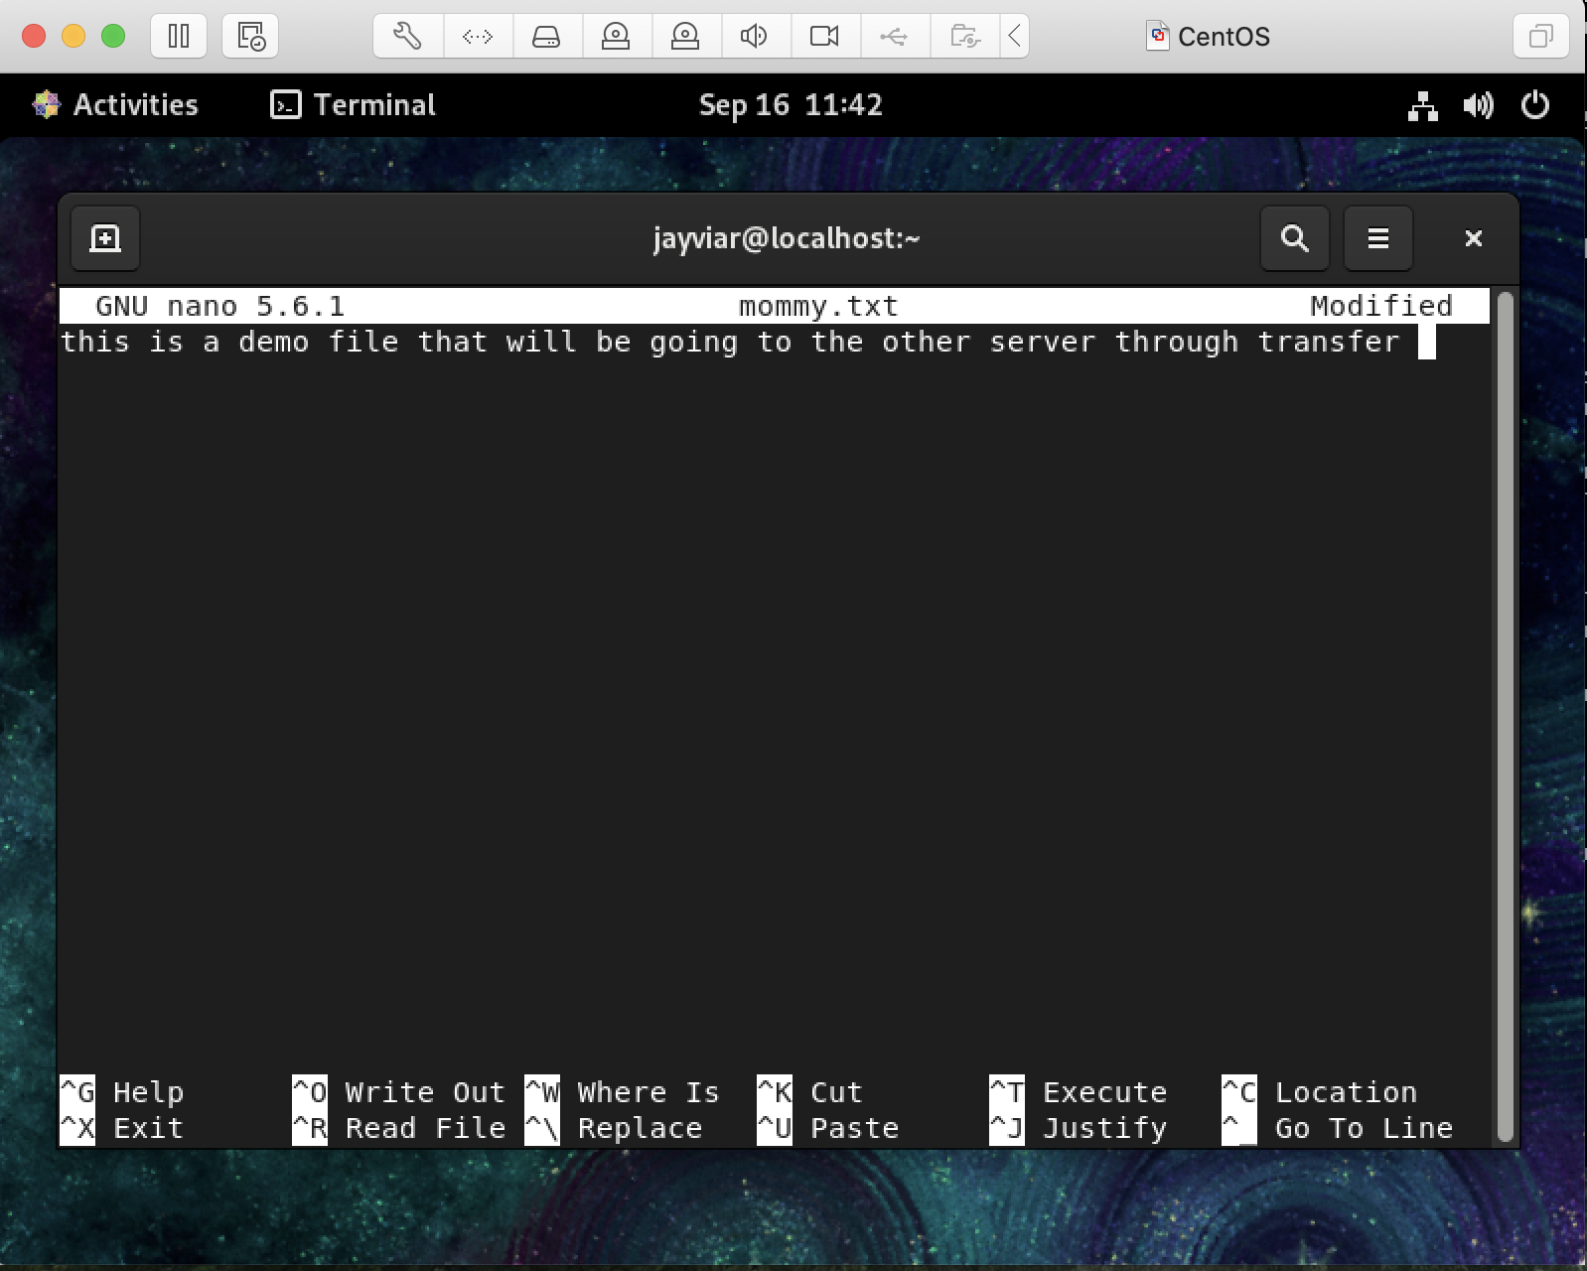

3)

Now to send this file off we will simply use the SCP command with the syntax of Scp-filename-ReceivingServerName@IPaddress

*Note\* After this command is run, we will need to enter the password of the server receiving the file. Not the one we are currently running on*

Our results should look like this



4)

Finally, to confirm the file was delivered we will look at the server that received the file and check if it is there. A quick ls command on the server will show us the file in the home directory unless specified elsewhere. We will next run the cat command just to display what we originally typed on the file at the beginning of the share.

